Are you trying to run an application and get the following error???

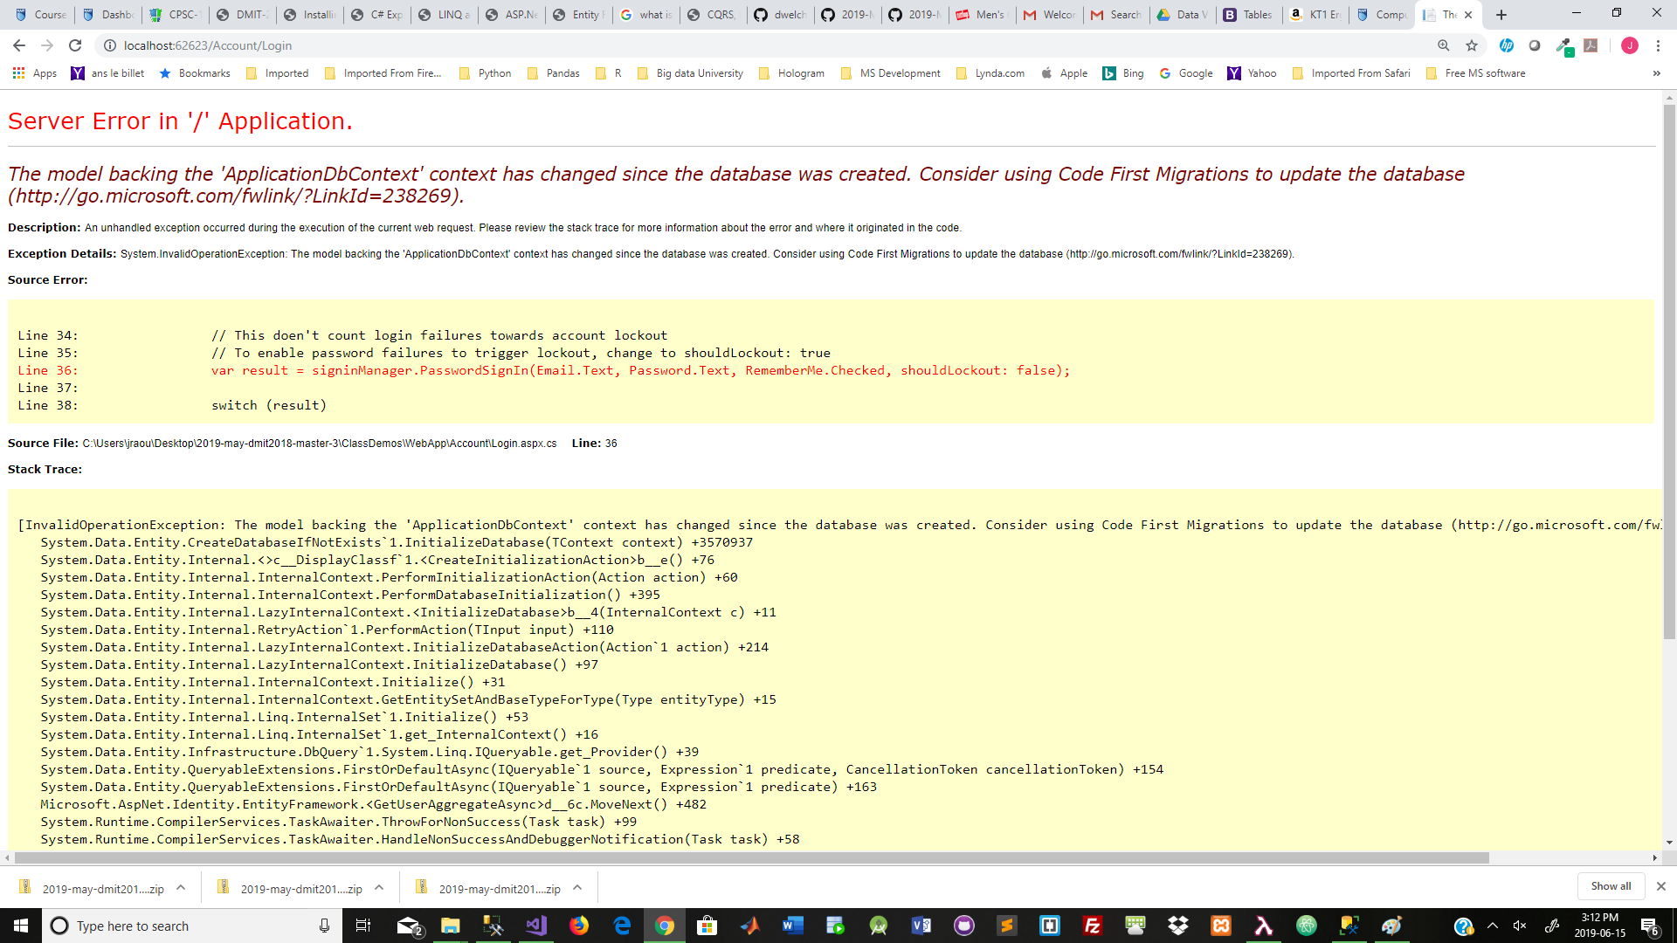

The problem is that you have tried to do security and your ApplicationUser class is different then the ApplicationUser definition in one you are currently using

Scenario

You implemented a version of security with an ApplicationUser class with one definition.

Your application runs and creates a set of security tables in your database.

You then open a different solution that has a different Application class definition.

You try to run this different solution and get the error above.

It is complaining because your original created set of security table has a different impression of the security ApplicationUser model (table definition) then the second solution.

Fix.

Close everything but your sql

Delete the security tables

Close your sql

Logoff

Logon

Open your sql

Restore the original sql database

Delete any security tables in the database

Open the solution you wish to use

Run the solution

Tried to logon

This should restore the security tables using the ApplicationUser definition in the solution you are running.

So..

If you run different solutions testing security you need to ensure that the ApplicationUser class definition is the same as the definition that originally created the security tables.

don